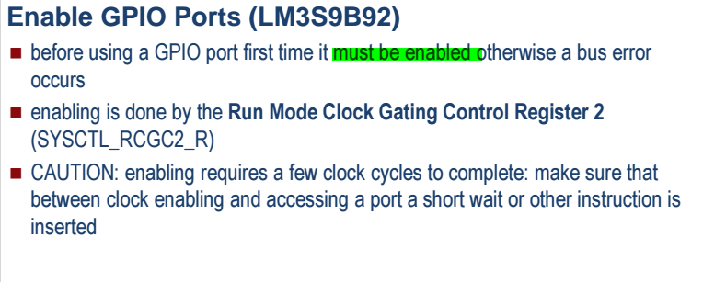

FOR gpio-_portx_dir_r for dont care values set corresponding register to zero to avoid high voltage in input by accident and damage the cpu or change a data .

